**LoRaWAN MULTICHANNEL INDOOR GATEWAY WITH 3G/4G**

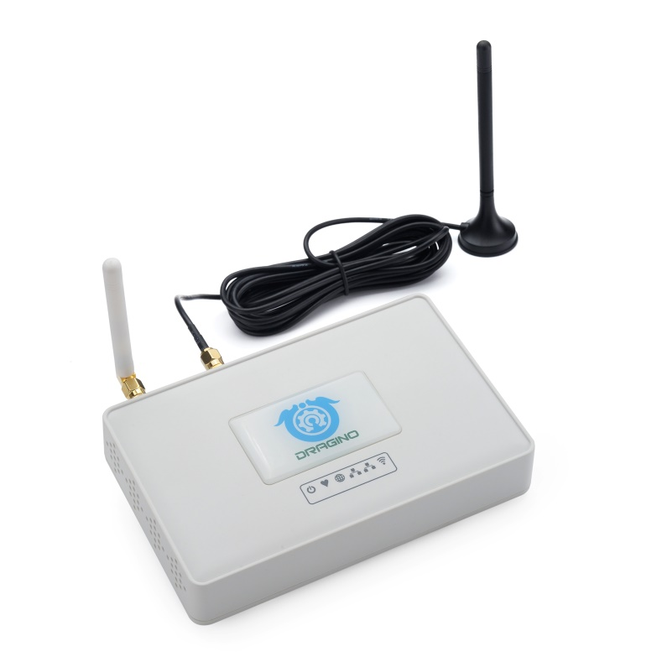 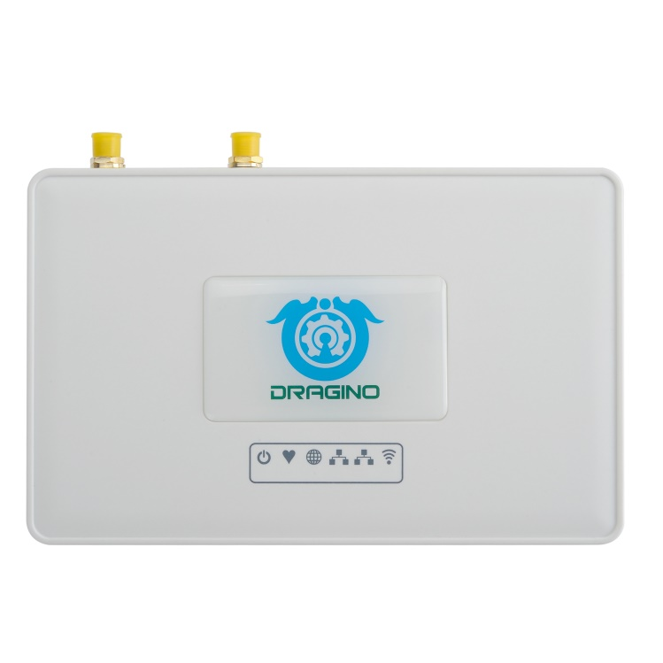

**Description**

The LG308 EC25 is an open source LoRaWAN Pico Gateway. It lets you bridge LoRa wireless network to an IP network via WiFi, Ethernet, or 3G/4G cellular via optional LTE module. The LoRa wireless allows users to send data and reach extremely long ranges at low data-rates.

The LG308 uses semtech packet forwarder and fully compatible with LoRaWAN protocol. It includes a SX1301 LoRa concentrator + 2 x SX1257, which provide 10 programmable parallel demodulation paths.

LG308 has pre-configured standard LoRaWAN frequency bands to use for different countries. User can also customized the frequency bands to use in their own LoRa network.

LG308 has optional built-in LoRaWAN server. System integrator can use it to integrate with their existing IoT Service without set up own LoRaWAN server or use 3rd party LoRaWAN service.

**LoRa Specification**

* 1 x SX1301 + 2 x 1257 LoRa Transceiver

**General Specification**

* 10M/100M RJ45 Ports x 2
* 1 x 2.4G WiFi (802.11 bgn)
* 1 x USB host port
* 1 x Mini-PCIe Interface
* Power Input: 12v, 1A

**Cellular 4G LTE**

* Quectel EC25 LTE module ( Clink the link to find the right model for your region)
* Micro SIM Slot
* Internal 4G Antenna + External 4G Sticker Antenna.
* Up to 100Mbps downlink and 50Mbps uplink data rates
* Worldwide LTE,UMTS/HSPA+ and GSM/GPRS/EDGE coverage
* MIMO technology meets demands for data rate and link reliability in modem wireless communication systems